9/8/2020

C3 LAB

WAV (7.74MB) saves it exactly the way I recorded the music. The best quality is found here. It is a lossless audio.

MP3(742 KB) took up less space than WAV. It is a compressed file making it easier to find on the internet and send via email. The recording still sounds good.

MP2 (27.8MB) does not compress the recording as much as MP3 but the recording sounds like MP3.

These are the WAV, MP3 and MP2 files I compared

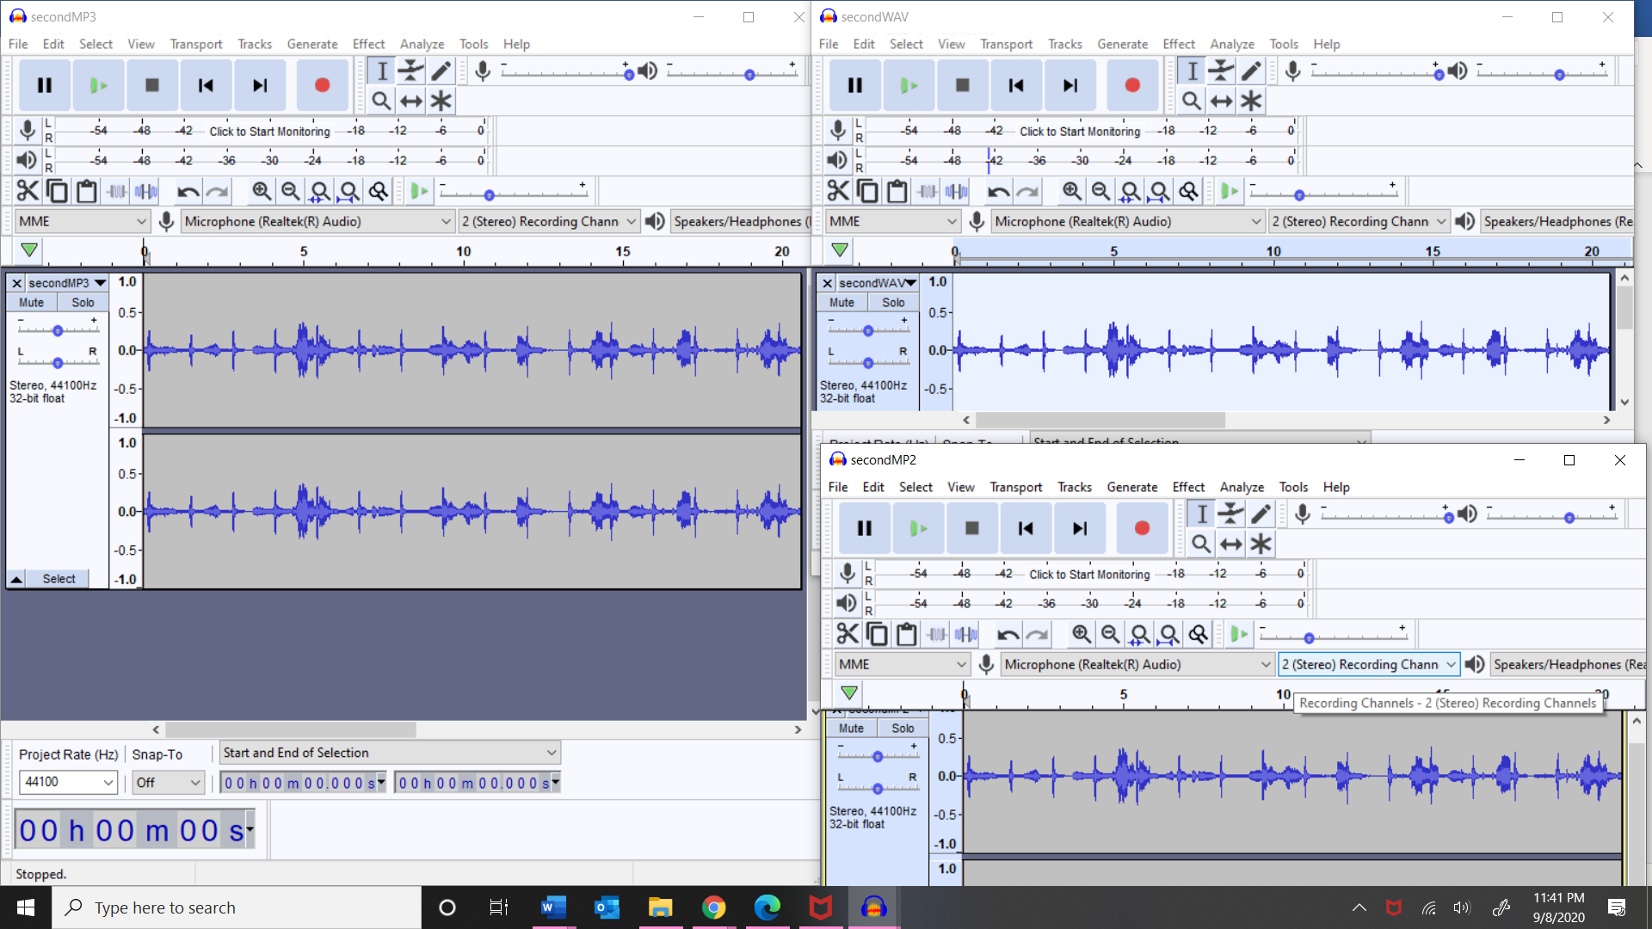

Table summary

|  |  |  |
| --- | --- | --- |
| Audio format | Size | property |
| WAV | 7.74MB | Lossless, best kind, like original recording. |
| MP3 | 742 KB | Compressed file, easy to share, recording sounds good. |
| MP2 | 27.8MB | Takes much space, sounds similar to MP3 |